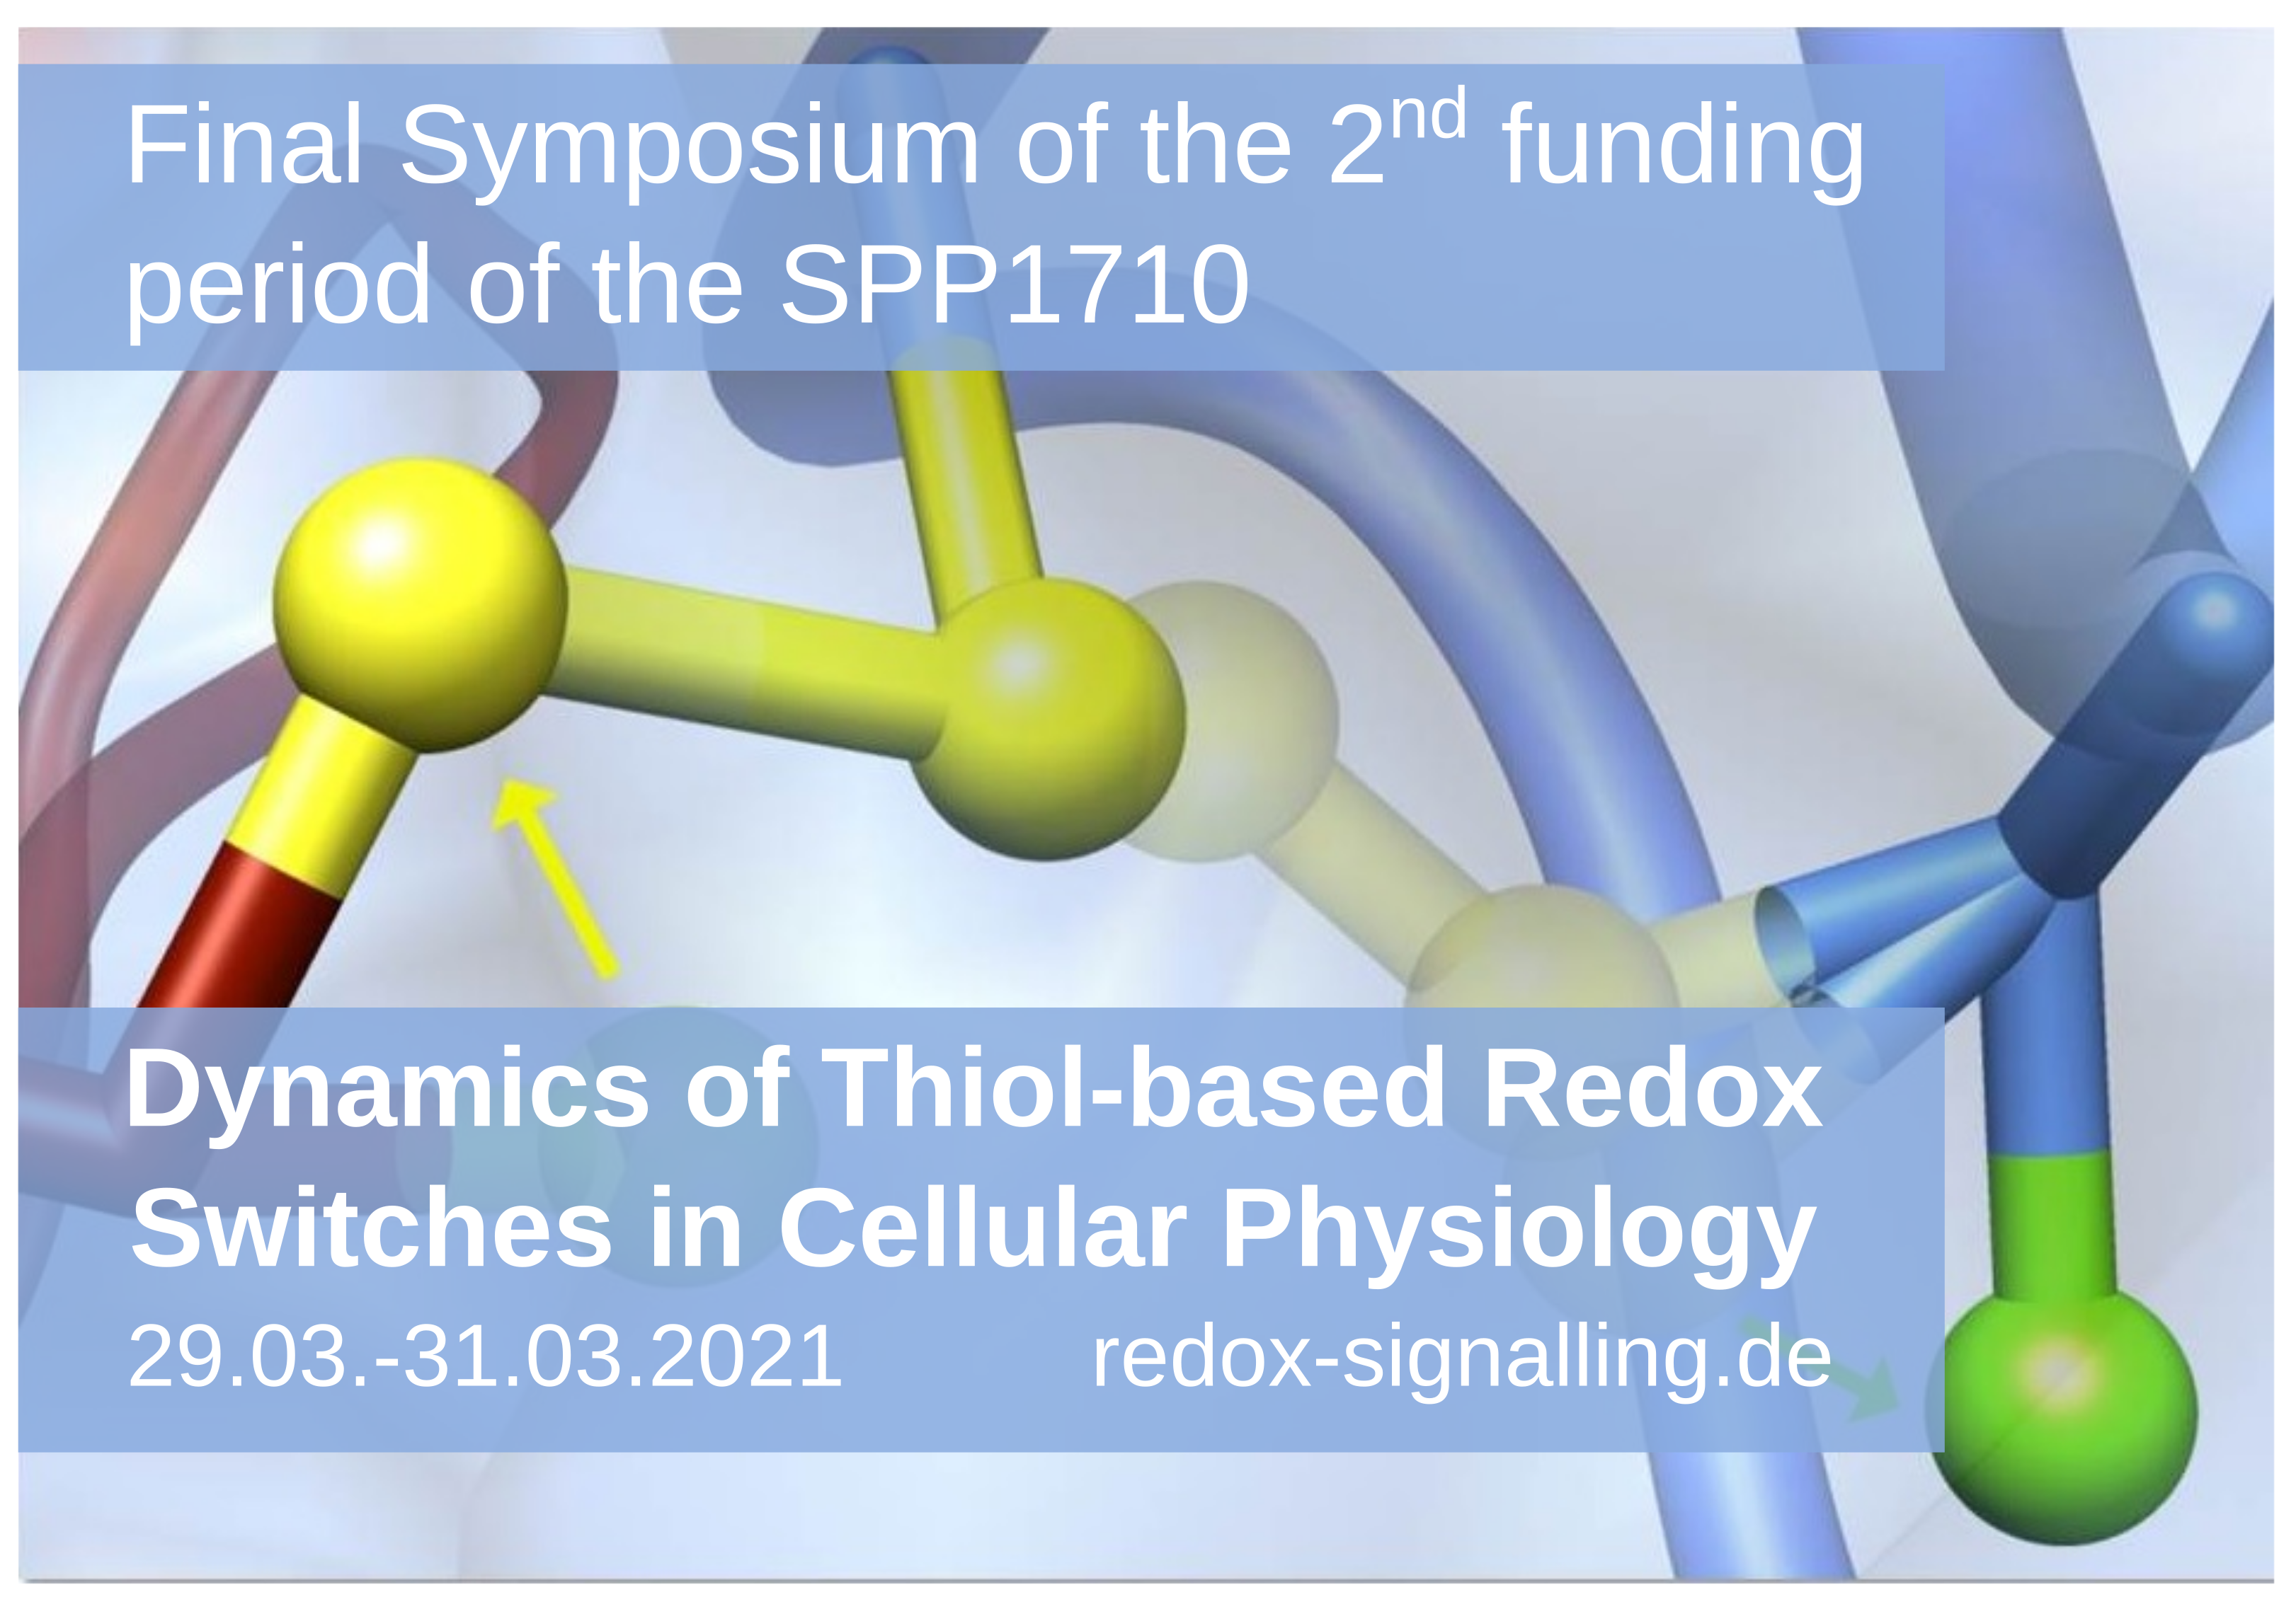
Registration
Final Symposium of the 2nd funding period of the DFG priority program SPP1710

Please submit this registration form to registration@redox-signalling.de until 28th of February 2021

Name:
University:
Department:
Position:
I am submitting an abstract for a poster
yes () no ()

In addition, I would like to present my project as a short talk
yes () no ()

Abstract title:
Authors:
Abstract (max. 150 words):

